

Session 1

Assignment 1 Question

*Session 1: Assignment 1*

**Table of Contents**

1. Introduction

2. Problem Statement

3. Output

**1. Introduction**

This assignment will help you to consolidate the concepts learnt in the session.

**2. Problem Statement**

**Task 1:**

1.

Install Jupyter notebook and run the first program and share the screenshot of the output.

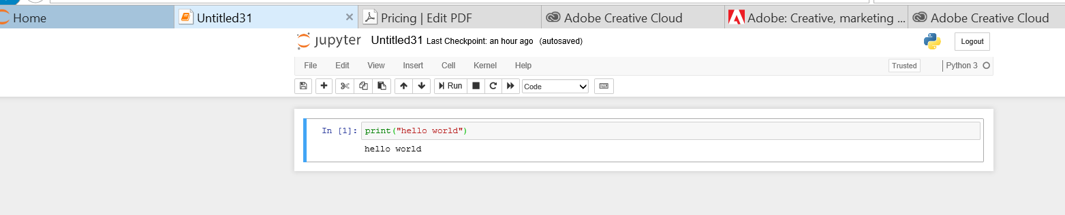

2.

Write a program which will find all such numbers which are divisible by 7 but are not a multiple of 5, between 2000 and 3200 (both included). The numbers obtained should be printed in a comma-separated sequence on a single line.

=>for i in range(2000,3201):

if(i%5!=0) and (i%7==0):

print(i, end=',')

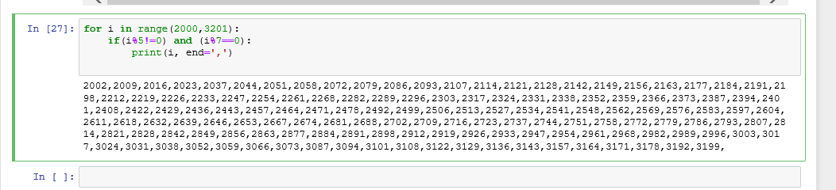

3.

Write a Python program to accept the user's first and last name and then getting them printed in the the reverse order with a space between first name and last name.

Name=input("enter first name and last name: ")

print(Name[::-1])

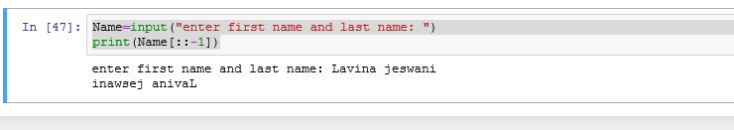

4.

Write a Python program to find the volume of a sphere with diameter 12 cm. Formula: V=4/3 * π * r 3

diameter=12

radius= diameter/2

volume=4/3*(3.14*(radius**3))

print("volume=%f cm cube "%volume)

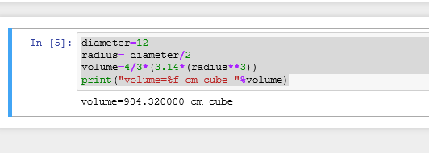

**Task 2:**

1.

Write a program which accepts a sequence of comma-separated numbers from console and generate a list.

values=input("enter the numbers: ")

l=values.split(",")

print (“list=”,l)

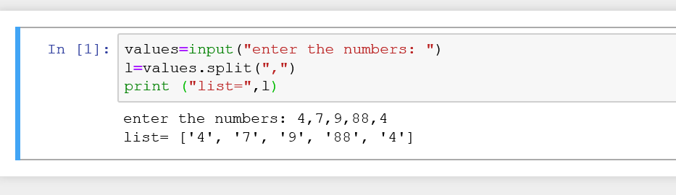

2.

Create the below pattern using nested for loop in Python.

*

* *

* * *

* * * *

* * * * *

* * * *

* * *

* *

*

for j in range(1,11):

i=1

while(i<=j and j<=5):

print('*',end=' ')

i+=1

while(j>5 and i<=10-j):

print('*',end=' ')

i+=1

print("\n")

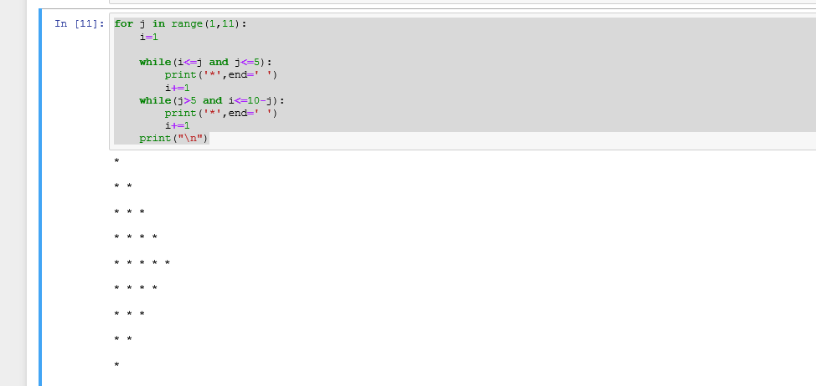

3.

Write a Python program to reverse a word after accepting the input from the user.

**Sample Output:** Input word: AcadGild Output: dilGdacA

Input=input("enter input: ")

print(Input[::-1])

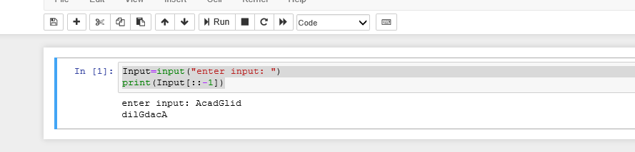

4.

Write a Python Program to print the given string in the format specified in the **sample output.**

WE, THE PEOPLE OF INDIA, having solemnly resolved to constitute India into a SOVEREIGN, SOCIALIST, SECULAR, DEMOCRATIC REPUBLIC and to secure to all its citizens

**Sample Output:**

WE, THE PEOPLE OF INDIA,

having solemnly resolved to constitute India into a SOVEREIGN, !

SOCIALIST, SECULAR, DEMOCRATIC REPUBLIC

and to secure to all its citizens

print("WE, THE PEOPLE OF INDIA,\n\t having solemnly resolved to constitute India into a SOVEREIGN,\n\t\t SOCIALIST, SECULAR, DEMOCRATIC REPUBLIC \n\t\t and to secure to all its citizens")

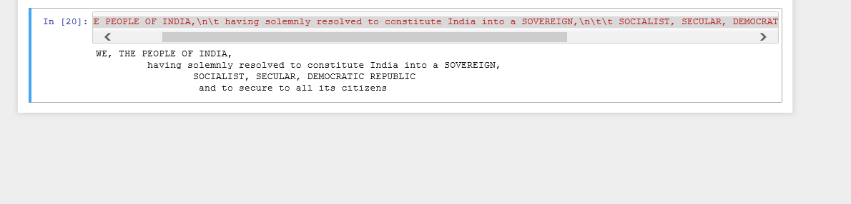

**NOTE: The solution shared through Github should contain the source code used and the screenshot of the output.**

**3. Output**

N/A